**User Manual for the “Garbage collecting robot”**

# 

# ROBOT

* Charge the robot for about 6 hours (240v)
* Then keep the robot at the initial point and switch on it.
* Robot will perform assigned tasks for about 24 hours (working hours =24h)

# 

# MOBILE APPLICATION.

# Before Working with Your Mobile Application,

* CAUTION: Your mobile phone has to achieve minimum requirements for working with mobile application.
  + Minimum OS: android KitKat or higher
  + Ram: 1GB.
  + Facilities: Good internet connection such as 3G or higher.

# How to install the mobile application?

1. Before installing the application change some settings: -
   1. Setting->Security->Device administration.
   2. Untick the **unknown sources**.
2. You can install the app from **APK** **file**.
3. Connect your phone to internet.
4. Launch the app form your phone menu list.
5. Assign the web server address to mobile application
   1. App Main menu ->Settings
   2. Put this web address on the text field as a server address
   3. **gacorobot**.**000webhostapp**.**com**.
   4. Then click **save** button.

# How to work with application.

* After installing mobile application, you will able to see the main screen as follows.

## Main screen

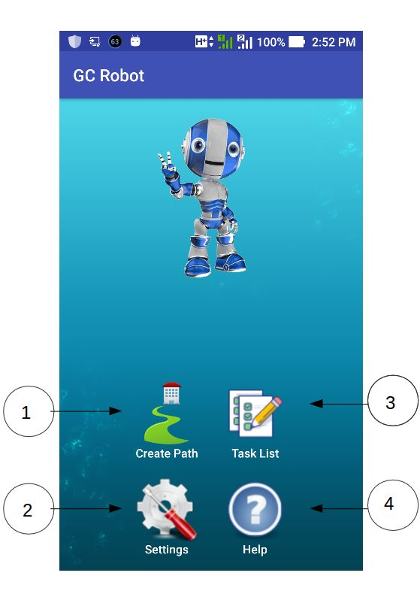

1. **Create** **path** interface provides options to Create dynamic paths and assign it to the robot.
2. **Task** **List** Interface provides options to View all the tasks related to garbage processing (ex: like a report) and able to make some changes.
3. **Settings** interface provides option to change the web server address.
4. **Help** interface provides some basic description of main functions.

## Create dynamic path

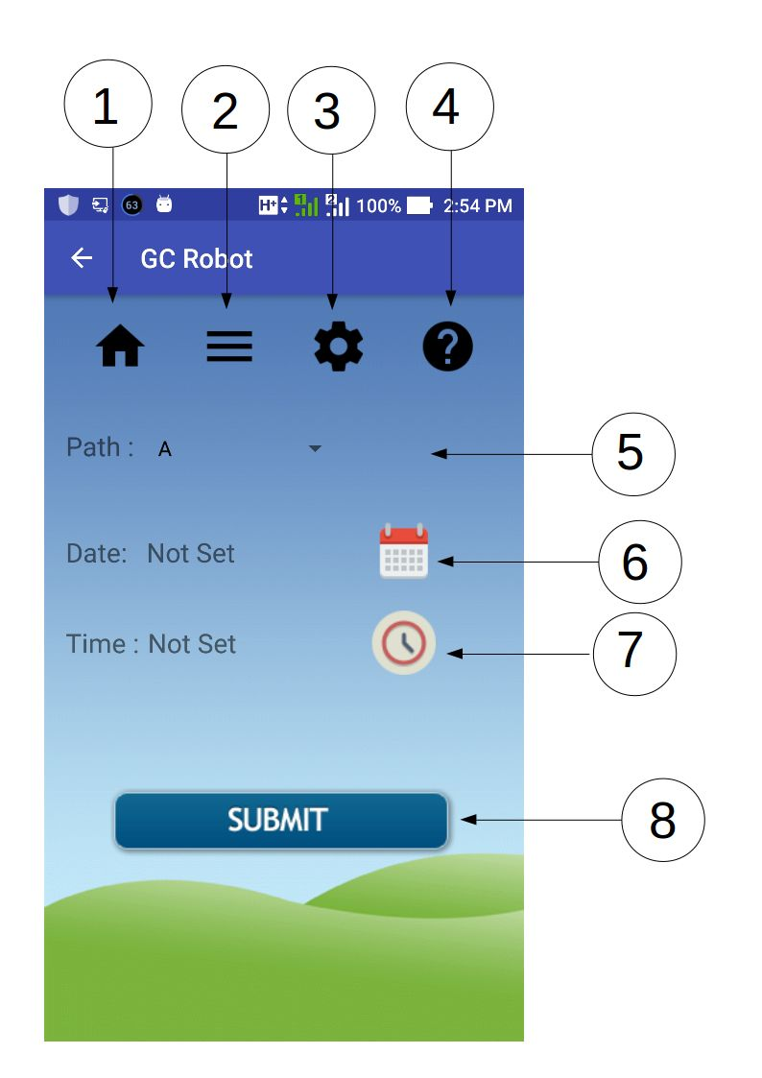

### Navigation buttons:

1. **Home:** navigate to the main menu screen.
2. **Task View:** navigate to task view screen.
3. **Settings:** navigate to the app settings screen.
4. **Help:** navigate to help screen.

### Function buttons and tools:

1. **Path**: Select the path from drop down view such as A, B, C (These paths are related to actual paths that robot can navigate).
2. **Date:** give the date to start the garbage collecting process.
3. **Time:** give the time to start the garbage collecting process.
4. **SUBMIT:** send all the dynamic navigation details to web server.

## View all the tasks

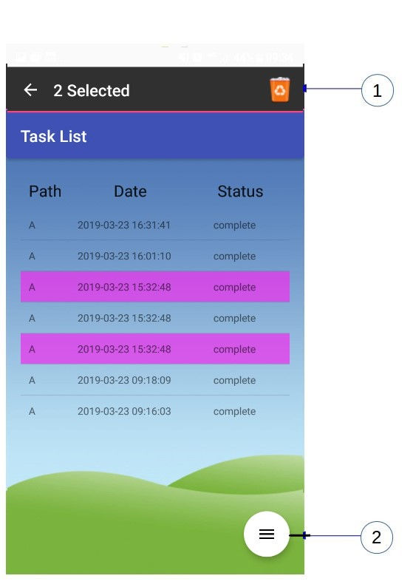

1. After selecting the tasks from the list view ,delete button will be appeared on the action bar. Click on the button to delete the tasks.
2. Provide some option to change to the list view.

## Task List Options

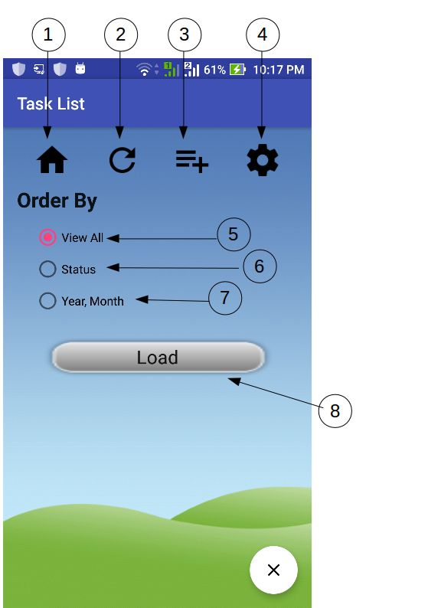

### Navigation buttons:

1. **Home:** navigate to the main menu screen.
2. **Task View:** navigate to task view screen.
3. **Settings:** navigate to the app settings screen.
4. **Help:** navigate to help screen

### Functions

1. **View all:** view all the tasks on the list.
2. **Status**: view the tasks related to the status such as pending, Not Yet, complete
3. **Year, Month:** view the tasks related to the year and month given by the user.
4. **Load:** load tasks to list view.

# WEB APPLICATION.

# How to use the web server?

1. Put the server URL on the web browser.



## Home page

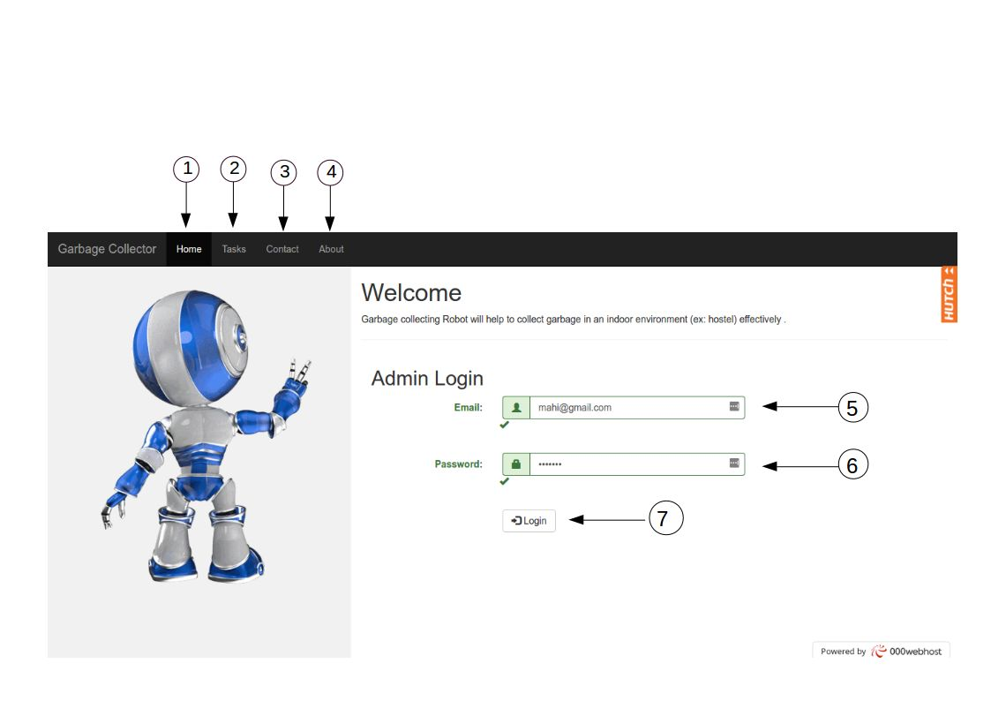

1. **Home:** navigate to the home page.
2. **Tasks**:navigate to the tasks page that page will display all the tasks.
3. **Contact:** navigatetocontact page that page displays some contact information.
4. **About:** some details about system.
5. **Email:** put the email address to login to the system.
6. **Password:** put the password to login to the system.
7. **Login:** login button to login to the system.

## User dashboard

1. **Home:** navigate to user dashboard.
2. **Status:** change the order of the tasks table.
3. **Robot:** navigate to robot panel page.
4. **Add Task:** navigate to task inserting page that page provide option to add new task with date and time.
5. **Delete:** navigate to task deleting page that page provide option to delete the tasks.
6. **Profile:** navigate to profile page that page provides some option such as add user, delete user, change password.
7. L**ogout:** navigate to main page that page use to logout the web server.
8. **Delete:** optionto delete the task from task table.

## Add Task

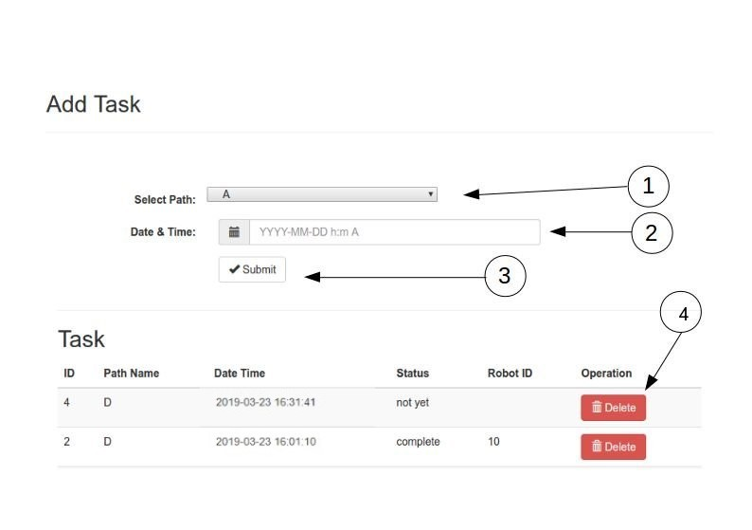

1. **Path**: Select the path from drop down such as A, B, C (These paths are related to actual paths that robot can navigate).
2. **Date and time:** give the date and time to start the garbage collecting process. Follow this format when you are inserting the date and time YYYY-MM-DD h:m A ex: 2019-02-02 1:10pm.
3. **Submit:** submit button to save dynamic path.
4. **Delete:** delete the task from table.

## Remove Task

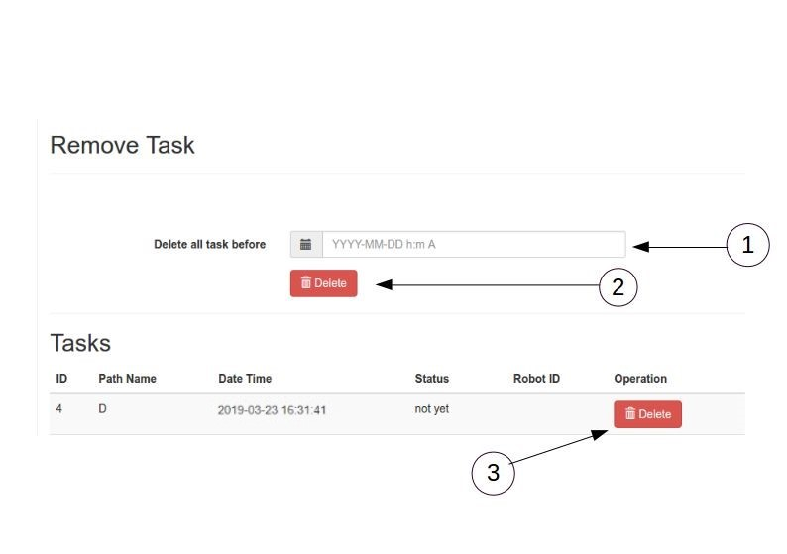

1. **Delete all the task before:** You can insert the date and time; you hope to delete the tasks until that time.
2. **Delete:** this button provide option to delete all the path record (Tasks) until user inserted date and time.
3. **Delete:** user can delete particular task from table.

## Robot Panel

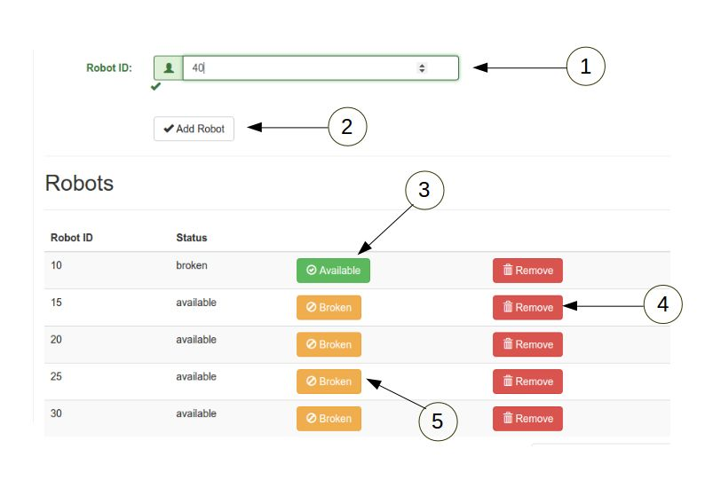

1. **Robot ID:** put new robot id in here.
2. **Add robot:** button to add new robot
3. **Available:** if robot is fixed after broken you can manually change the robot status from broken to available.
4. **Remove:** user can remove the robot from server.
5. **Broken:** if robot is broken, user can manually change the robot status from available to broken.

## Add User

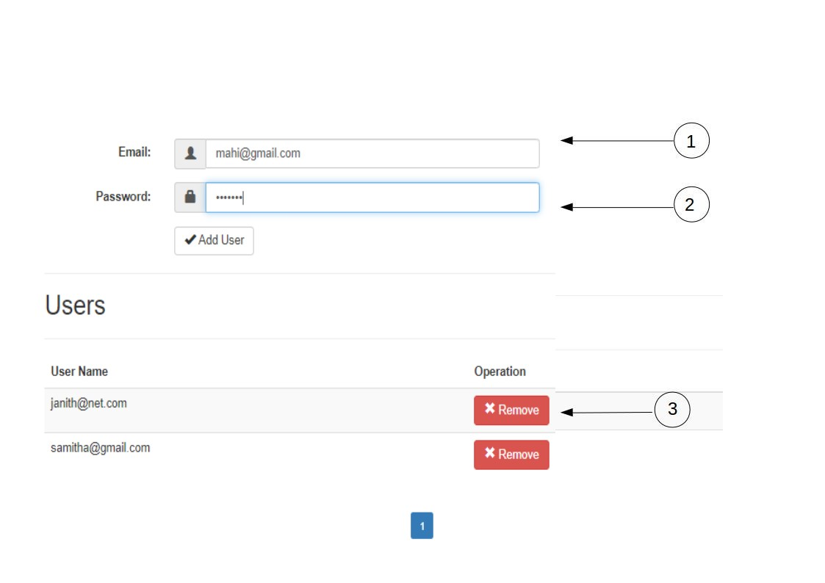

1. **Email:** put the new user’s email address.
2. **Password:** put the new user’s password.

**Add user:** add new user to system

1. **Remove user:** remove user from system.

## Change password

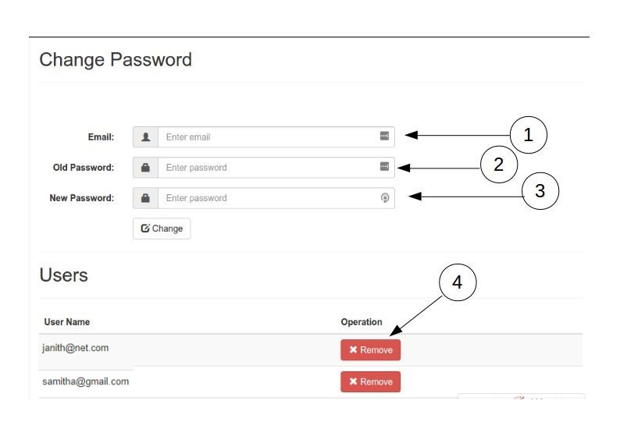

1. **Email:** Insert theuser’s email address.
2. **Old password:** Insert the user’s old password.
3. **New password:** Insert the user’s new password and click the button “Change” to change the previous password.
4. **Remove:** remove the user from the server.